pdated:
July 2025: Clearer verbiage on Spelling /Grammar/ Format Issues
March 2025: Added clarification for unavailable content and suggestion types
March 2025: Added additional guidance for JP market
July 2024: Added additional guidance for open box prefixes
Introduction
The role of App Store Suggestions is to help App Store users find a specific App or content quickly and easily. Additionally, suggestions can also provide inspiration for new searches, leading users to discover new content and relevant categories they might not have otherwise found.
Understand the Feature:
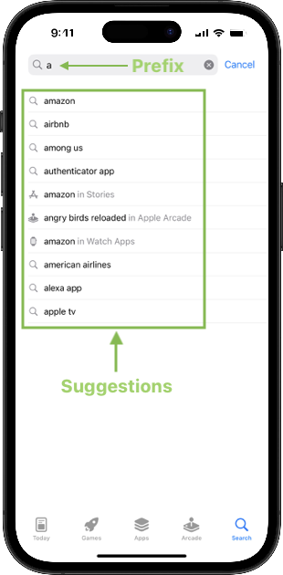Feature
On your iOS device, check out the suggestions for the prefix you're evaluating for a better understanding of how the feature works.
Types of Suggestions
Suggestions can be categorized into two types: navigational and functional. You should be aware of this distinction to better assess the intent and expected outcome of each suggestion.
Navigational suggestions are intended to direct users to a specific app or developer. These typically include exact app names or developer names and selecting them should lead directly to the intended result.
Examples of navigational suggestions:
doord → doordash
h → hulu
app → apple tv
nin → nintendo co., ltd.
Functional suggestions are broader and often refer to a category, purpose or feature of apps, which can return a wider variety of relevant apps.
Examples of functional suggestions:
pho → photo editor
gam → games for kids
nest → home automation apps like nest
Entity suggestions
Suggestions that point to Stories, Developers, Watch apps, and Apple Arcade content will be marked with a blue banner under the output.
In-App Events
Suggestions can point to an In-App Event. By searching the name of the suggestion in App Store on iPhone, it can be verified whether the suggestion points to an In-App Event and if the event is still on-going with status of either "Now Available" or "Happening Now".
Apple Arcade Games
Apple Arcade games will not show ratings and reviews in the App Store Preview. You will need to search for the game in the App Store and click on it to see the ratings and determine popularity.
Open box ␣
Some user queries in BaseLine end with the symbol known as open box: ␣
The open box ␣ symbol represents a space that the user entered after their search term(s). For example, if the user entered the word 'door' and then hit the space bar, that specific prefix would be displayed in BaseLine as [door␣]. If the user did not enter a space after, the prefix would be displayed as [door]. It's important to consider the likely and possible user intents with the added space when you see an open box ␣ in the prefix.
Note: If the prefix contains an open box, one-word suggestions can still be relevant.
Complex Suggestions
You may encounter suggestions that are longer than the standard search suggestions and structured like a sentence.
For these suggestions, relevance should still be assessed. However, it might be more difficult to assess popularity of the exact suggestion. While the absolute popularity of the intent of the suggestion might be low, it can still lead to users to interesting results and invite them to explore. In these situations, please also consider how likely a suggestion sparks the interest of the user.
Completing the Task
Goal of the evaluation: "Does this suggestion meet the primary intent of the user typing the prefix?"
Research Prefix Intent
The purpose of this evaluation is to evaluate the relevance of a suggestion for a given text string. We want to ensure that the generated suggestions add value to the users. Each user that navigates to search in App Store is looking for either a specific app or an app with a specific function. When evaluating the suggestions, keep in mind that users typing the same prefix might each have a different intent.
Use search engines such as Bing, Google, etc. to help understand the likely intents of the inputs. When forming a web search query it helps to narrow down intent by adding terms like "iphone" or "app store" to the prefix you're researching, e.g. ['prefix' iphone] or ['prefix' app store].
Rate the Suggestion
The grades on the relevance scale are as follows:
Primary Intent (Perfect)
Secondary Intent (Good)
Acceptable Intent
Not relevant
Spelling/Grammar/Format Issues
Unavailable
Unacceptable: Concerns
Unacceptable: Spam
Problem: Other
Add Comment
Each rating must be explained in the comment box [even if “optional” is indicated - rating comments are always mandatory]. The comment should be concise and must only explain why the rating chosen is the correct one in application of the guidelines.
Relevance Scale
Primary Intent (Perfect)
This is the most obvious, frequent and common intent for a specific prefix and satifies the primary intent of the user.
Perfect suggestions complete the prefix, are popular, add value, and 'make sense' given the length of the string.
Note that suggestions that repeat a valid search query are perfect suggestions; for example 'lyft' → lyft.
Misspelled suggestions cannot be rated as Perfect suggestion, but should instead be rated as Spelling /Grammar/ Format Issues.
star war → Star Wars™: Galaxy of Heroes is a Perfect primary intent.
lego mind → ‘lego mindstorms ev3’ Perfect (Name in the App Store: LEGO® MINDSTORMS® EV3 Home)
Examples of perfect suggestions:
a → amazon
a → amazon in Stories (Entity suggestion. [amazon] in Stories returns story content pointing to some very popular apps in the App Store
a → amex (app of American Express)
Secondary Intent (Good)
A secondary intent, on the other hand, is less likely, or would be a less popular intent compared to a primary intent or leads users to explore new content. Suggestions that broaden or narrow the scope of the prefix are considered good suggestions.
Less popular but relevant suggestions can be rated Good.
Suggestions that narrow down to a specific feature, genre, category, or user group can be rated as Good. These should be rated as Good only when the user intent is clear.
For example, if your prefix is 'pok' and the suggestion is 'poker - texas hold em'. While it fits the basic intent of the prefix, it is slightly too specific for the prefix 'pok'. The output 'poker - texas hold em' would be a Perfect suggestion for the prefix 'poker' though, since the user has clearly made the intent for finding poker related apps clear.
Examples of Good suggestions:
basketball games → basketball games for sports gaming enthusiasts
audiobook →audiobook apps for bedtime listening
podcast → podcast apps for daily commute
piano learning → piano learning apps for music enthusiasts with interactive lessons
games → puzzle games
games → games with parental controls
games → safe games for kids
a → amzn mobile llc in Developers (Entity suggestion. Less likely to be an intent for the developer)
a → amazing bomberman in Arcade (Entity suggestion. This Apple Arcade game is less popular)
a → anime games (slightly specific, a less likely intent of the prefix 'a')
a → american eagle outfitters in Developers (it's much more likely that the user is looking for American Eagle clothing)
photo␣ → what are some good social networking apps for photo and video sharing
remin → apps for staying organized with shopping lists, to-do lists, and reminders
Acceptable Intent
A suggestion that may be too specific, vague and not popular.
Too Specific/Unpopular
pok → pokémon go wallpaper hd
Since we cannot confidently determine the user's intent for the prefix 'pok', better and less specific suggestions would be 'pokémon', 'pokémon go', 'poker'
Incomplete/Too Vague
sp → sport (A better suggestion would be "sports".)
Outdated Apps
Suggestions pointing to apps that have had no updates for 3 or more years and have poor or no reviews
These apps are outdated and may provide poor user experience due to lack of updates.
Not in the Official Language of the Market
A suggestion that is not in the official language of the market but does have a text match to the prefix is Acceptable.
These apps or searches could be a possible intent.
Redundant Suggestions
A suggestion that includes extra words or phrases that are obvious or redundant. e.g. for iPhone, for ipad, app, for iOS.
Exception: If the prefix includes the first few letters of the word ‘app’ or ‘free’ completion of the prefix is not considered extra language. For example, for the prefix ‘doordash a’, the suggestion ‘doordash app’ makes sense and can get a rating of Perfect.
Examples of Acceptable suggestions:
a → army game studio in Developers (an unpopular, unknown developer)
a → akeed (too specific; a food delivery app for a region in Oman)
a → ally auto mobile pay (too specific of a suggestion for the prefix)
a → azumio inc. in Developers (an unpopular, unknown developer)
a → amtrack forum (too specific and unpopular)
ang → apps that support angle and pressure sensitivity for water color, pencil, pen tools, etc.
fac → apps with touch id or face id for mobile banking security
Spelling /Grammar/ Format Issues
A suggestion has an error if it contains misspellings, grammar errors or formatting issues.
However, it is not an error for a suggestion to omit a subtitle or tagline. If the suggestion accurately represents the main part of the app's title, it should be considered correct. Subtitles often follow a colon (:) or a dash (-). For example, for an app named Too Good To Go: End Food Waste, the suggestion 'too good to go' is perfectly acceptable.
When judging for spelling and grammar, you must ignore capitalization. Do not penalize a suggestion for its case (e.g., spotify vs. Spotify), as this is not considered a Spelling /Grammar/ Format error.
Misspelling
star war → starwars galaxy of heros (‘star wars’, and heroes’ are misspelled)
Spacing Errors
face →face time
can → candycrushsaga
door␣’ → ’door dash’ - correct spelling is doordash without the space
Not Relevant
Unrelated text match - Any partial matches within the text or unrelated to the user intent
mat → postmates
tar → games with grand theft auto v-style controls and targeting in a city environment
lik → recommend entertainment apps like a lie detector game
Unrelated to App Search
suggestions should contain content related to app search and app discovery. For instance suggestions pointing to general knowledge or trivia are not pertinent to app search queries and should be marked as Not Relevant.
w → who won the last superbowl?
fa → who is the ceo of facebook?
Queries with partial text matches with a part of the prefix
motion ca → e-go pure motion - carsharing
Unacceptable: Spam
Suggestions that appear to be gibberish.
pdf → app ! ! ! ! ! ! ! !! pdf scan
pdf → ****pdfscan****
Unacceptable: Concerns
suggestions containing content related but not limited to the following topics that may be offensive or sensitive:
- Toxicity
- Hatred
- Discrimination
- Bias
- Vulgarity/Obscenities
- Restricted or Regulated Content
- Sexual Material
- Self-Harm
- Violence
- Restricted Apps
games → Single-Player games with guns that feel satisfying to shoot (violence)
Suggestions pointing to removed apps due to regulations. These apps have been restricted by the government.
Example : Crypto currency apps are not available in China.
suggestion: 欧易 (OKX)
suggestion: 币安交易平台 (Binance)
Tik → TikTok (App is banned in India)
dating → dating apps for girls (inappropriate for user group)
Unavailable
Not Available in the Market
Android-only apps, or apps that have been removed from the App Store or points to content that do not exist in the store at this time.
vid → app ! video editor add music (Suggestions pointing to non-existent app)
te → temple run 4 (Suggestions pointing to non-existent app )
crea → create your own avatar now! (In-App Event that is not available; It no longer satisfies the prefix intent)
Important:
When evaluating app navigational suggestions for app availability on your iOS device, it is crucial to type the suggestion exactly as it appears on the BaseLine page. Searching with only a partial or incomplete name may not recall the app on the search results page. This includes variations in spacing, punctuation or word order.
In the example shown below, the left side demonstrates the correct suggestion as it appears on BaseLine, including the colon. On the right side, the same suggestion is typed without the colon, showing that even a small deviation can prevent the correct app from appearing in the search results. Failing to type the full and correct suggestion leads to incorrect ratings.
photo␣ → photo ai: image maker
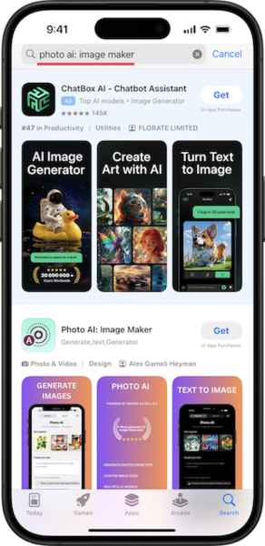Correct Spelling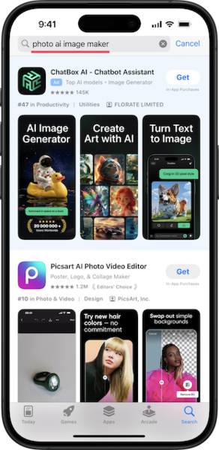Incorrect Spelling

Problem: Other
Use this rating only if there is an error or problem with the task itself in BaseLine. For example, there's no output to judge. If such cases should exist, contact your support team immediately.
Problem: Other rating should not be used if the content is unavailable in App Store but it is still possible to determine relevance between prefix and output based on side searches on Google and/or on other platforms such as App Annie.
Additional Guidelines for Japan

If the suggestion is in the same character set as the prefix, the rating depends on the relevancy and suggestions that are not in expected form are downgraded. 'Spelling/Grammar/Format' is used only for the obvious misspelling.

Examples:
- If the expected form of the intent is not clear, the rating depends on the relevancy.
Prefix: おんがIntent: おんがく/音楽 (music) → expected form is not clear
Suggestion 1: おんがく(music) → Primary Intent (Perfect)
Suggestion 2: おんがくかい (music concert) -> Acceptable Intent (too specific and not many relevant content)
Suggestion 3: おん がく(music) → Spelling/Grammar/Format (suggestion with space)
Suggestion 4: おんげく(music) → Spelling/Grammar/Format (misspelling of おんがく)
- If the intent is a word from foreign language, the expected form is Katakana and suggestions in Katakana are rated as Primary Intent (Perfect).

Prefix: だいえIntent: ダイエット(diet)
Suggestion 1: だいえっと (diet) → Secondary Intent (Good) (expected form is ダイエット)
Suggestion 2 : だいえっとぼっくす (diet box) → Secondary Intent (Good) (expected form is ダイエットBOX)
Prefix: ふぉろIntent: フォロー (follow)
Suggestion 1: ふぉろー (follow) → Secondary Intent (Good) (expected form is フォロー)
Suggestion 2: ふぉろーちぇっく insta (follow check insta) insta → Secondary Intent (Good) (expected form is フォローチェックinsta)

- If the suggestion is app navigational, the suggestion has to be in the same form as the official title to be rated as Perfect.

Prefix: しろIntent: しろ(Castle/white)
Suggestion 1: しろ → Primary Intent (Perfect) (expected format is not clear)
Suggestion 2: しろとドラゴン(castle and dragon) → Secondary Intent (Good) (expected form is 城とドラゴン )
Suggestion 3:しろねこテニス (white cat and tennis) →Secondary Intent (Good) (expected form is 白猫テニス)

